Siemens VSD Modbus Configuration in PecStar
How to configure a Siemens VSD according to its Modbus mapping with PecStar?
For example, the Modbus mapping of Siemens VSD#1 is as below:
Items | Modbus Adress | Parameter | Format | Scale
1 | 40000 | Status Word 1 | UINT32* | Default=K0032
2 | 40001 | Status Word 2 | UINT32# | Default=K0033
3 | 40002-40003 | Speed | UINT32
4 | 40004 | Output Voltage | UINT16
5 | 40005 | Output Current | UINT16
6 | 40006 | Output Power | UINT16
7 | 40007 | Motor Torque | UINT16
8 | 40008 | DC Bus Voltage | UINT16
*The following illustrates the meanings of every bit of Status Word 1 register.
Bit0=Ready to power up
Bit1=Ready
Bit2=Run
Bit3=Fault
Bit4=OFF2
Bit5=OFF3
Bit6=Power-on inhibit
Bit7=Alarm
Bit8=Setpoint-actual value deviation
Bit9=PZD control requested
Bit10=Comparison frequency reached
Bit11=Undervoltage
Bit12=Main contractor energized
Bit13=RFG active
Bit14=Clockwise rotating field
Bit15=KIP/FLN active
# The following illustrates the meanings of every bit of Status Word 2 register.
Bit16=Restart-on-the-fly active
Bit17=Synchronism has been reached
Bit18=Overspeed
Bit19=External fault 1
Bit20=External fault 2
Bit21=External alarm
Bit22=Alarm i2t drive converter
Bit23=Fault, converter overtemperature
Bit24= Alarm, converter overtemperature
Bit25=Alarm, motor overtemperature
Bit26= Fault, motor overtemperature
Bit27=Reserve
Bit28= Fault, motor stalled/locked
Bit29=Bypass contractor energized
Bit30= Alarm sync. error
Bit31= Pre-charging active
To read the parameters, please make configurations following the steps:

Step I Start PecConfig

Step II Add a site
Right-click on the Communication Setup folder from the left-hand pane, select New…, and the Site Node Properties window appears. Set the Driver Type to MODBUS Protocol Master Site Driver. Set the Serial Port parameters to match the port and device.
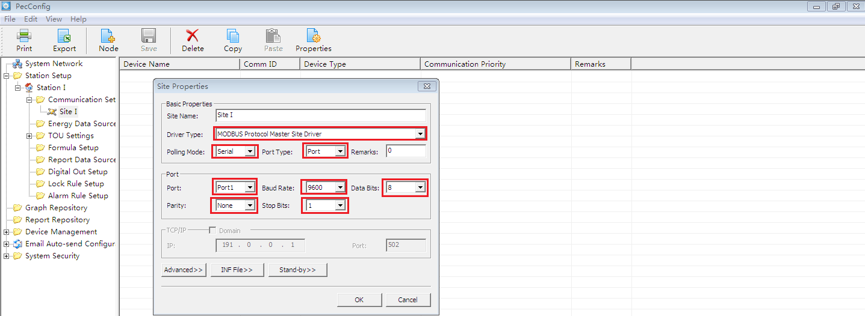
Add a device. Click + to expand the Communication Setup folder. Right-click on the Site I, select New…, and the Device Node Properties window appears. Set the Type to ModbusMeter.
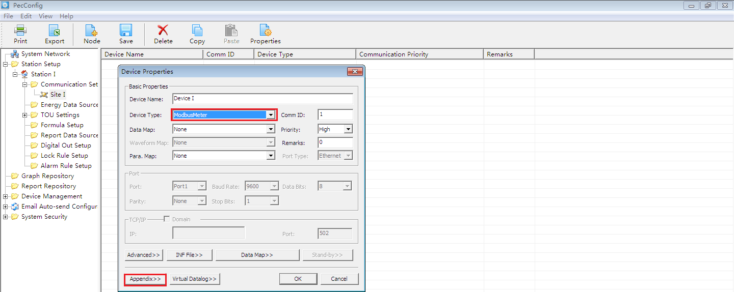

Right-click the Device I and select Properties. Click Appendix>> from the Device Properties box and you will see the following box.
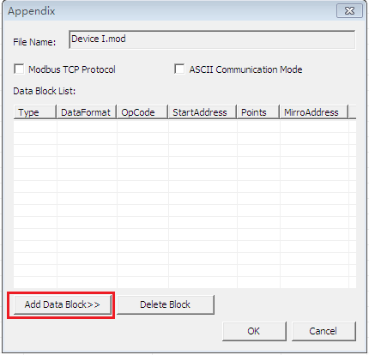

Step III Edit Modbus Block properties
Click Add Data Block>> from the Appendix setup for MODBUS Protocol Master Site Driver’s configuration file window, and the Block Edit dialog box appears.
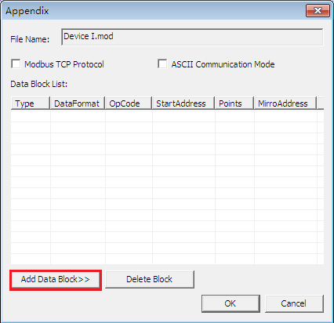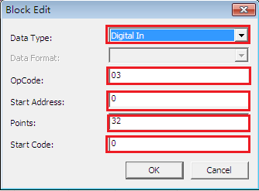
Data Type: Set to Analog In for analog measurements and set to Digital In for status measurements.
Data Format: Set to NUM_U32INT for unsigned 32-bit integer.
NUM_U16INT: unsigned 16-bit integer.
NUM_S16INT: signed 16-bit integer.
NUM_U32INT: unsigned 32-bit integer.
NUM_S32INT: signed 32-bit integer.
NUM_U32MFP: unsigned 32-bit float.
NUM_S32MFP: signed 32-bit float.
OpCode: Enter 03 (the function code 03 is read registers)
Start Address: Enter 0. Set Start Address according to the device’s Modbus mapping.
Source No.: Enter 1. It’s the number of parameters with the same data format.
Start Code: Enter 0. It’s same with the code number of every parameters in PecConfig which has marked by red rectangle in the following figure.
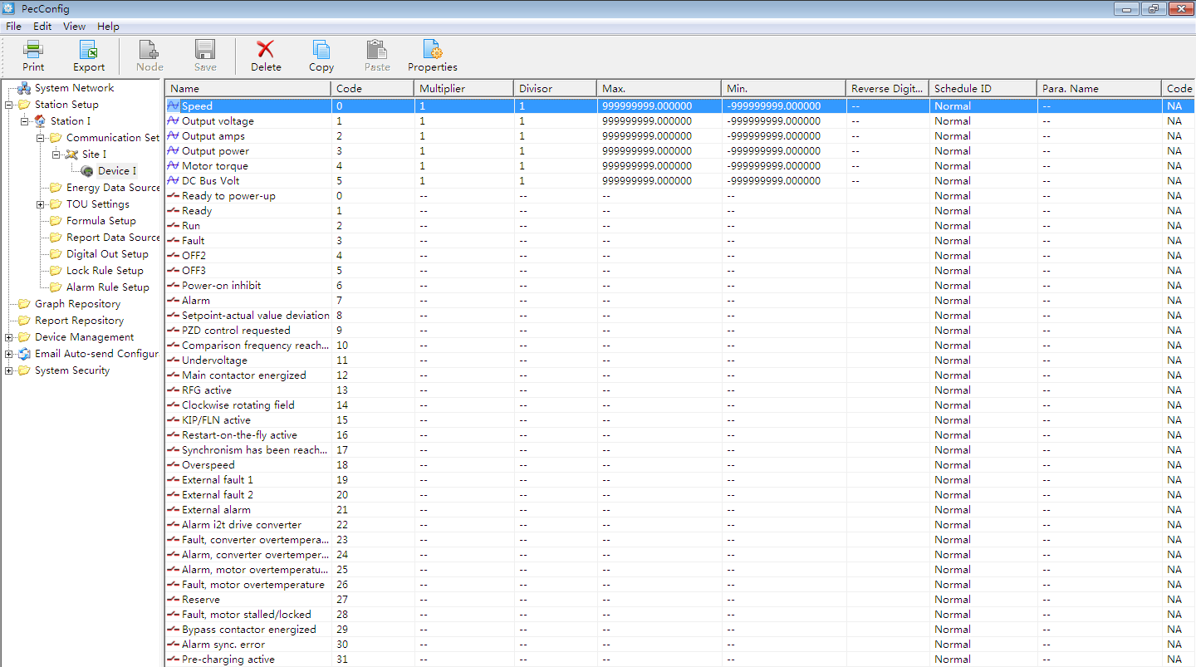
Click OK from the Block Edit window. The Modbus block added is listed in the Data Block List area.
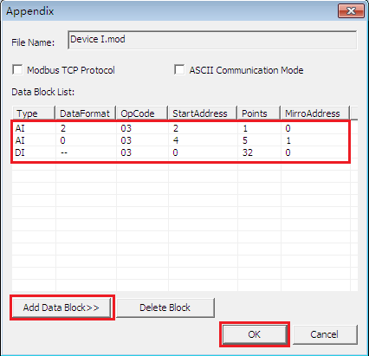
Click Add a Block>> to add other Modbus block.
After all Modbus blocks are added, click OK from the Appendix setup for MODBUS Master Site’s configuration file window.
Click Ok from the Device Node Properties window.

Step IV Import Device SNF
Import SNF file by right click on the Device I and select Import SNF File.
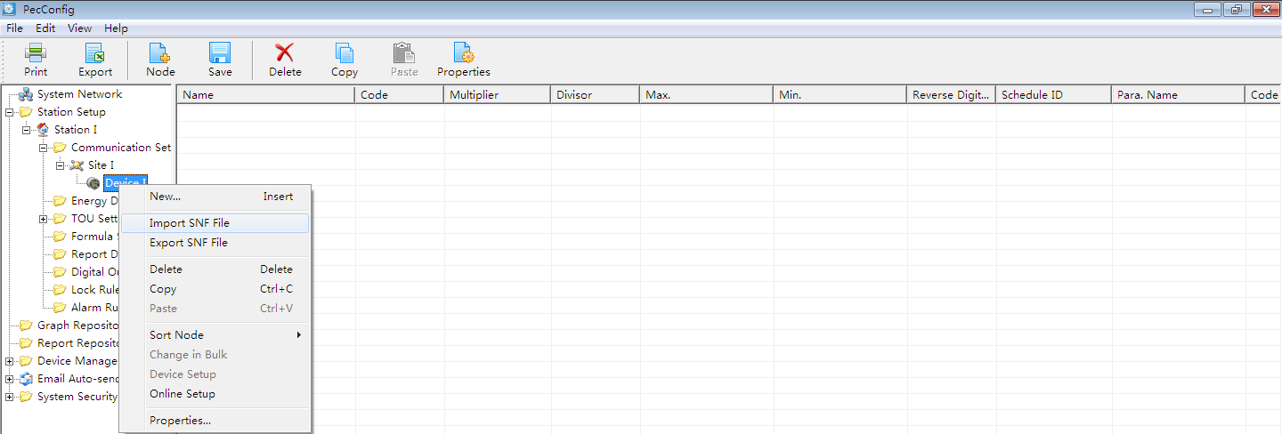
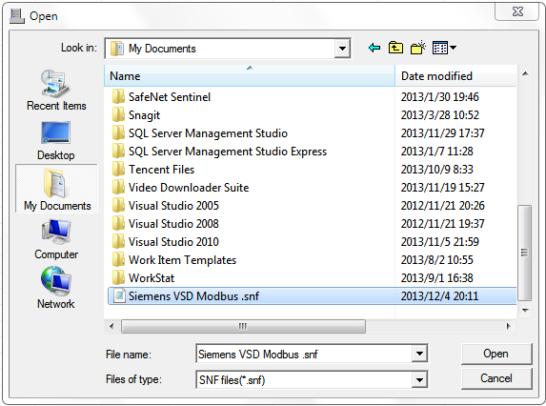
Save to database. Click Save from the tool bar. Exit PecConfig.
Start Front. Check the readings with the device.
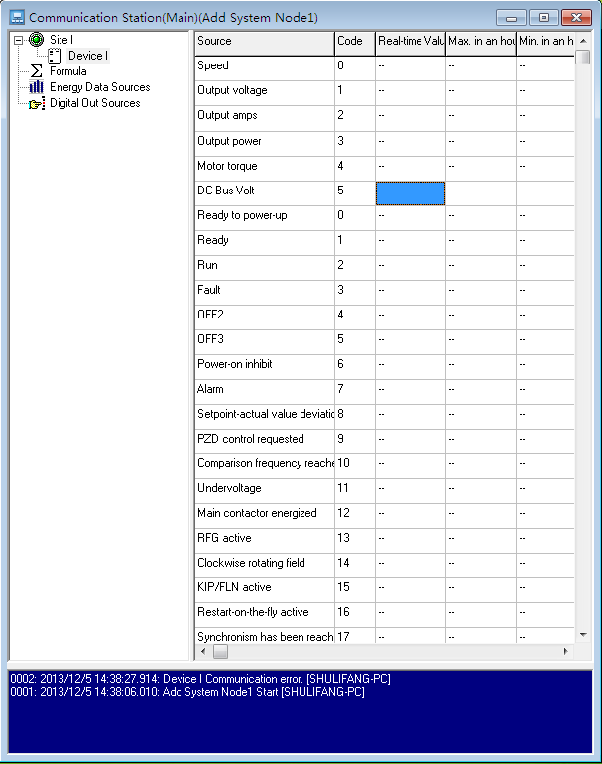
Note: Select a Type from the drop-down list. No need to match the Type to your device.

Appendix A SNF File of Siemens VSD#1
A0=Speed
A1=Output voltage
A2=Output amps
A3=Output power
A4=Motor torque
A5=DC Bus Volt
D0=Ready to power-up
D1=Ready
D2=Run
D3=Fault
D4=OFF2
D5=OFF3
D6=Power-on inhibit
D7=Alarm
D8=Setpoint-actual value deviation
D9=PZD control requested
D10=Comparison frequency reached
D11=Undervoltage
D12=Main contactor energized
D13=RFG active
D14=Clockwise rotating field
D15=KIP/FLN active
D16=Restart-on-the-fly active
D17=Synchronism has been reached
D18=Overspeed
D19=External fault 1
D20=External fault 2
D21=External alarm
D22=Alarm i2t drive converter
D23=Fault, converter overtemperature
D24=Alarm, converter overtemperature
D25=Alarm, motor overtemperature
D26=Fault, motor overtemperature
D27=Reserve
D28=Fault, motor stalled/locked
D29=Bypass contactor energized
D30=Alarm sync. error
D31=Pre-charging active

